Annex B:

Supporting Use of the Pratt Pouch:
A Training for Lay Workers and
Traditional Birth Attendants
Introductory Information
for Participants

November 2013

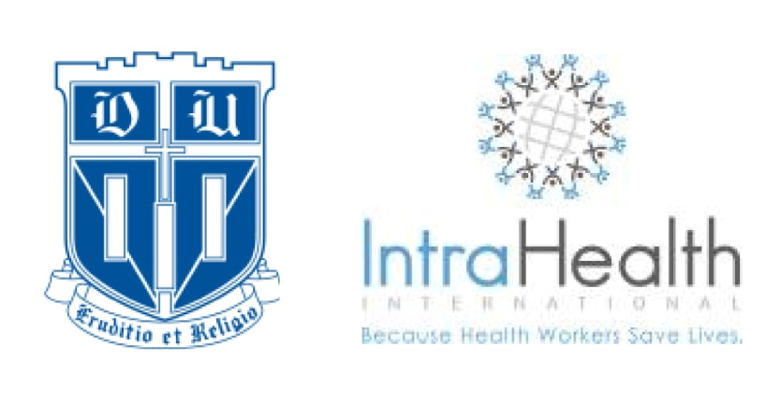
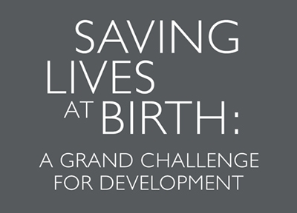
This product is made possible through the generous support of the Saving Lives at Birth Partners: The United States Agency for International Development (USAID), the Government of Norway, the Bill and Melinda Gates Foundation, Grand Challenges Canada and the World Bank. It was prepared by IntraHealth and does not necessarily reflect the views of Saving Lives at Birth partners.

Background
The Pratt School of Engineering at Duke University has developed and tested a foilized, easy-to-use polyethylene pouch that extends the shelf-life of antiretroviral drugs (ARVs) for up to 12 months. This novel single-dose pouch, called the Pratt Pouch, can be filled via syringe and heat-sealed by pharmacists or other trained workers. It can then be provided to women infected with the Human Immunodeficiency Virus (HIV) early in pregnancy, thus enabling them to provide the medication to their newborn directly if unable to deliver at a health facility. In partnership with Duke University, IntraHealth International developed this training manual for preparing lay workers and traditional birth attendants to use and support the pouches. This material, which provides guidance for a four (4)-hour workshop, was field-tested in 2012 with P/PAs at three sites in Namibia: Windhoek, Ondangwa and Oshikati, and in Zambia

About IntraHealth International
IntraHealth International (www.intrahealth.org), founded in 1979, has worked in more than 90 countries to empower health workers to better serve communities in need. In collaboration with governments, nongovernmental organizations and private-sector organizations, IntraHealth champions the needs and contributions of health workers—from doctors and nurses to community health workers to health facility managers—and works to ensure they have the tools, supplies, information, training and support they need to provide the communities they serve with the best possible opportunities for health and well-being.

Acknowledgements
This manual was developed and tested by Nina Frankel, Senior Technical Advisor for Workforce Development at IntraHealth International, under contract with Duke University. This manual was originally developed to field tested in Namibia and now adapted to Zambia for the implementation of the Pilot project. Support and guidance was provided by Robert A. Malkin, PhD and his team at Duke University: Lora Perry, Amanda Britt, Jennifer Arnold, Michael Maranzano, Alex Dahinten, Alexa Choy, and Joy Ekuta. Essential program support was also provided by IntraHealth International staff, Kate Stratten, Robert Dodge, and Yonas Asfaw.
A Saving Lives at Birth Challenge Grant provided the financial support that made this curriculum possible.

This notebook should include the following:
- Annex A: Participant Attendance Roster
- Annex B: Introductory Information
- Annex C: Workshop Schedule: Facilitators
- Annex D: Workshop Schedule: Participants
- Annex E: Overview Presentation
- Annex F: Illustrated Job Aid: Using the Pratt Pouch
- Annex G: Learning Guide: Using the Pratt Pouch
- Annex H: Illustrated Job Aid: Supporting Use of the Pouch
- Annex I: Learning Guide: Supporting Use of the Pouch
- Annex J: Pratt Pouch Register
- Annex K: Workshop Evaluation Form
- Annex L: Mother’s Instruction Guide

Goal of the Training
The goal of this training is to prepare lay workers and TBAs to use and support use of Pratt Pouches.

Participant Learning Objectives
By the end of this workshop, the participants will be able to:
- Describe the challenge of mother-to-child transmission of the HIV virus and the role of ARV prophylaxis in preventing this transmission
- Discuss what the Pratt Pouch is, how it is used and its importance in preventing mother-to-child transmission of HIV
- Demonstrate competence in using the Pratt Pouch.
- Demonstrate competence in supporting women to use the Pratt Pouch.

Acronyms
ARV: Antiretroviral
AZT Zidovuidine
HIV Human Immunodeficiency Virus
NVP Nevirapine
PMTCT: Prevention of Mother-to-Child-Transmission
TBA Traditional Birth Attendants
USAID: United States Agency for International Development

